EXPERIMENT NO. 1
OBJECTIVE:
Introduction to SQL and installation of Oracle Server.

DESCRIPTION:
DBMS
- A DBMS (Database Management System) is a software program used to manage a database. These programs enable users to access and modify database
- A DBMS is a complex set of software programs that controls the organization, storage, management, and retrieval of data in a database.
- A DBMS includes four main components, which are: Modeling Language, Data Structures, DB Query Language and Report Writer, and Transaction Mechanism.
Each of these components can be further broken down into smaller and more specific pieces, but it is the sum of these parts which are combined to create the management system around the particular database to be utilized.
- A database management system, or DBMS, gives the user access to their data and helps them transform the data into information.
Such database management systems include dBase, Paradox, IMS, and Oracle. These systems allow users to create, update, and extract information from their databases. Compared to a manual filing system, the biggest advantages to a computerized database system are speed, accuracy, and accessibility.
A database is a structured collection of data. Data refers to the characteristics of people, things, and events.
THE MAIN FOUR COMPONENTS OF DBMS:

MODELING LANGUAGE:
A modeling language to define the schema of each database hosted in the DBMS, according to the DBMS data model. The four most common types of organizations are the hierarchical, network, relational and object models.

DATA STRUCTURES
Data structures (fields, records, files and objects) optimized to deal with very large amounts of data stored on a permanent data storage device (which implies relatively slow access compared to volatile main memory).

DB QUERY LANGUAGE AND REPORT WRITER
A database query language and report writer to allow users to interactively interrogate the database, analyze its data and update it according to the users privileges on data.
- TRANSACTION MECHANISM:
A transaction mechanism, that ideally would guarantee the ACID properties, in order to ensure data integrity, despite concurrent user accesses (concurrency control), and faults (fault tolerance).
ORACLE :
Oracle is one of the powerful RDBMS product that provide efficient solutions for database applications. Oracle is the product of Oracle Corporation which was founded by LAWRENCE ELLISIONin 1977. The first commercial product of oracle was delivered in 1970. The first version of oracle 2.0 was written in assembly language. Nowadays commonly used versions of oracle are ORACLE 8, 8i & 9i Oracle 8 and onwards provide tremendous increase in performance, features and functionality.
FEATURES OF ORACLE :
- Client/Server Architecture
- Large database and Space Management
- Concurrent Processing
- High transaction processing performance
- High Availability
- Many concurrent database users
- Controlled availability
- Openness industry standards
- Manageable security
- Database enforced integrity
- Distributed systems
- Portability
- Compatibility
ORACLE SERVER TOOL :
Oracle is a company that produces most widely used server based multi-user RDBMS. Oracle server is a program installed on server hard-disk drive. This program must be loaded in RAM to that it can process the user requests. Oracle server takes care of following functions. Oracle server tools are also called as back end. Functions of server tool:
- Updates the data
- Retrieves the data sharing
- Manages the data sharing
- Accepts the query statements PL/SQL and SQL
- Enforce the transaction consistency
DDL – DATA DEFINATION LANGUAGE:
The SQL sentences that are used to create these objects are called DDL’s or Data Definition Language. The sql provides various commands for defining relation schemas, deleting relations, creating indexes and modify relation schemas. DDL is part of sql which helps a user in defining the data structures into the database. Following are the various DDL commands are
- Alter table & Create table & drop table
- Create index & drop index
- Create view & drop view
DML – DATA MANIPULATION LANGUAGE:
The SQL sentences used to manipulate data within these objects are called DML’s or Data Manipulation Language. It is language that enables users to access or manipulate data as organized by appropriate data model. By data manipulation we have
- Retrieval of information stored in database.
- Insertion of new information into database.
- Deletion of information from database.
- Modification of data stored in database.
TWO TYPES OF DML ARE:
- Procedural DML
- Non-procedural DML (Declarative )
FOLLOWING ARE DML COMMANDS ARE:
  - Select
  - Update
  - Delete
  - Insert
DCL – DATA CONTROL LANGUAGE:
The SQL sentences, which are used to control the behavior of these objects, are called DCL’s or Data Control Language. It is language used to control data and access to the database. Following are some DCL commands are
- Commit
- Rollback
- Save point
- Set transaction
A Data Control Language (DCL) is a computer language and a subset of SQL, used to control access to data in a database.
Examples of DCL commands include:
- GRANT to allow specified users to perform specified tasks.
- REVOKE to cancel previously granted or denied permissions.
The following privileges can be GRANTED TO or REVOKED FROM a user or role:
- CONNECT
- SELECT
- INSERT
- UPDATE
- DELETE
- EXECUTE
- USAGE
DATA TYPES OF SQL
- CHAR :
This data type is used to store character strings values of fixed length. The size in brackets determines the number of characters the cell can hold. The maximum number of characters (i.e. the size) this data type can hold is 255 characters. Syntax is CHAR(SIZE)
Example is CHAR (20)
- VARCHAR :
This data type is used to store variable length alphanumeric data. The maximum this data type can hold is 2000 characters. One difference between this data type and the CHAR data type is ORACLE compares VARCHAR values using non-padded comparison semantics i.e. the inserted values will not be padded with spaces. Syntax is VARCHAR(SIZE)
Example is VARCHAR (20) OR VARCHAR2 (20)
- NUMBER :
The NUMBER data type is used to store numbers (fixed or floating point). Numbers of virtually any magnitude maybe stored up to 38 digits of precision. Numbers as large as 9.99 * 10 to the power of 124, i.e. followed by 125 zeros can be stored. The precision, (P), determines the maximum length of the data, whereas the scale, (S), determines the number of places to the right of the decimal. If scale is omitted then the default is zero. If precision is omitted values are stored with their original precision up to the maximum of 38 digits.
Syntax is NUMBER (P, S) Example is NUMBER (10, 2)
- LONG :
This data type is used to store variable length character strings containing up to 2GB. LONG data can be used to store arrays of binary data in ASCII format. LONG values cannot be indexed, and the normal character functions such as SUBSTR cannot be applied to LONG values.
Syntax is LONG (SIZE) Example is LONG (20)
- DATE :
This data type is used to represent data and time. The standard format id DD-MM-YY as in 13-JUL-85. To enter dates other than the standard format, use the appropriate functions. Date Time stores date in the 24-hour format. By default, the time in a date field is 12:00:00 am, if no time portion is specified. The default date for a date field is the first day of the current month. Syntax is DATE
- LONG RAW :
LONG RAW data types are used to store binary data, such as Digitized picture or image. Data loaded into columns of these data types are stored without any further conversion. LONG RAW data type can contain up to 2GB. Values stored in columns having LONG RAW data type cannot be indexed. Syntax is LONGRAW (SIZE)
- RAW :
It is used to hold strings of byte oriented data. Data type can have a maximum length of 255 bytes. Syntax is RAW(SIZE)

Installing Oracle Database 10g on Windows
To install the Oracle software, you must use the Oracle Universal installer.
1. | For this installation you need either the DVDs or a downloaded version of the DVDs. In this tutorial, you install from the downloaded version. From the directory where the DVD files were unzipped, double-click setup.exe.  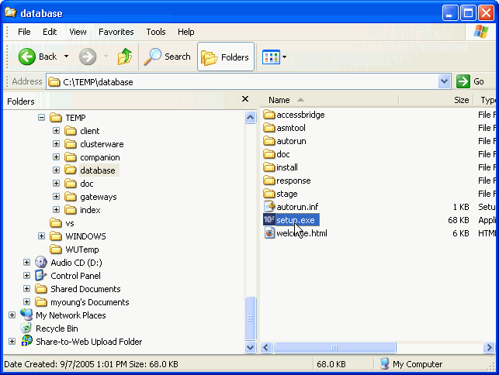  Fig. 1.1 Installation window
2. | The Oracle Universal Installer starts.  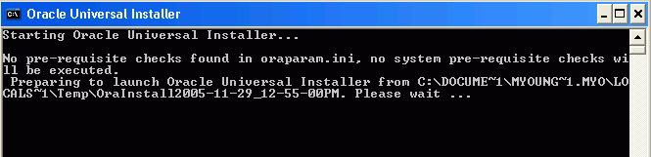  Fig.1.2 Command Prompt
3. | You will perform a basic installation with a starter database.Enterorcl for the Global Database and oracle for the Database Password and Confirm Password. Then click Next.  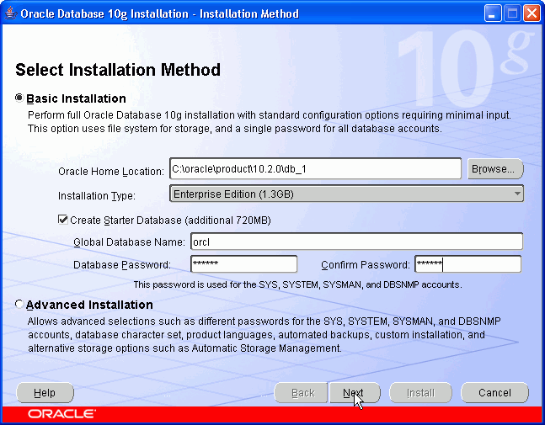  Fig. 1.3 Installation screen
4. | The installer now verifies that the system meets all the minimum requirements for installing and configuring the chosen product. Please correct any reported errors (warnings are OK) before continuing. When the check successfully completes (with or without warnings), click Next.  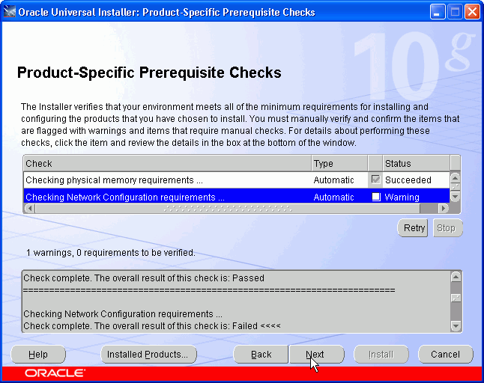  Fig. 1.4 Oracle universal Installer window
5. | If you received any warnings, you can proceed. Click Yes.  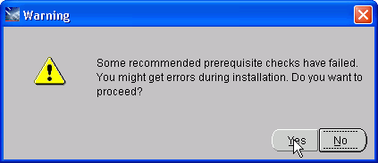  Fig. 1.5 Warning Window
6. | Review the Summary window to verify what is to be installed. Then, click Install.  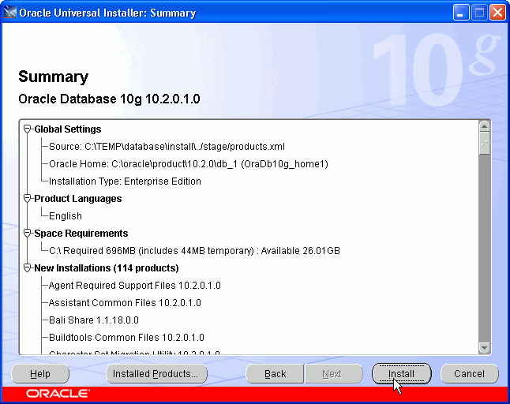  Fig. 1.6 Summary Window
7. | The progress window appears.  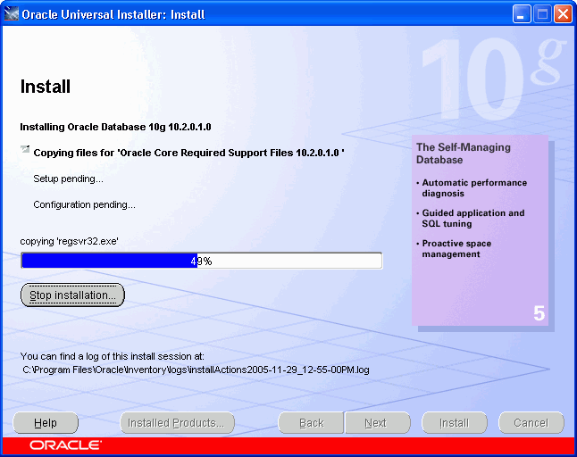  Fig. 1.7 Install Window
8. | The Configuration Assistants window appears.  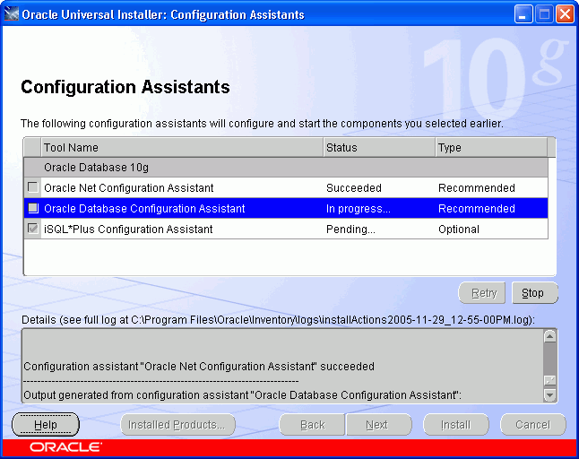  Fig. 1.8 Configuration Assistant Window
9. | Your database is now being created.  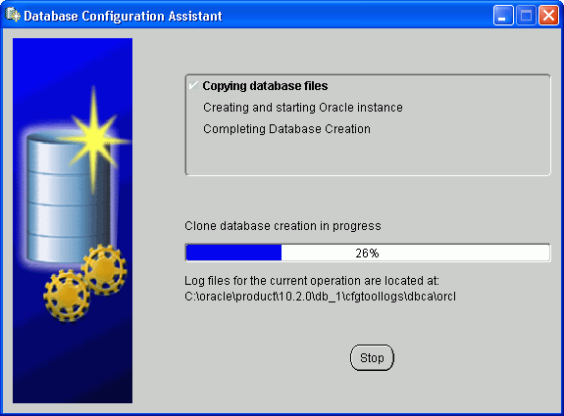  Fig. 1.9 Database Configuration Assistant Window
10. | When the database has been created, you can unlock the users you want to use. Click Password Management.  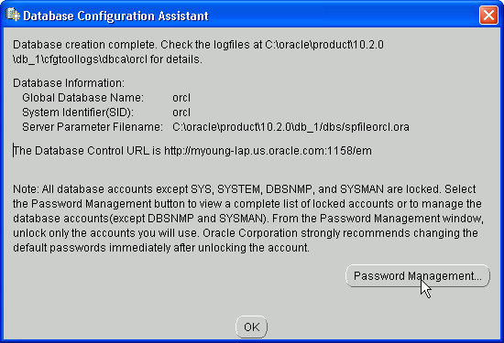  Fig. 1.10 Password Management Window
11. | Unlock SH, OE and HR users by clicking on the check mark in the Lock Account? column. Enter the same name as the user in the New Password and Confirm Password fields. For example,to unlock user, enter SH in the New Password and Confirm Password fields. Then, click OK.  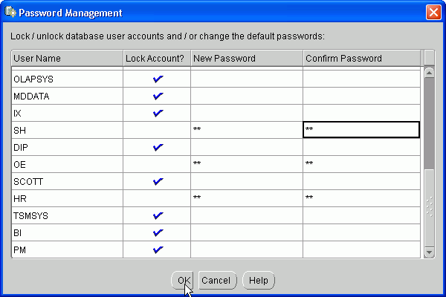  Fig. 1.11 Password Window Management Window 2
12. | Click OK again.  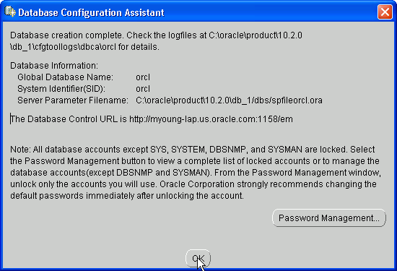  Fig. 1.12 Password Window Management Screen
13. | Click Exit.  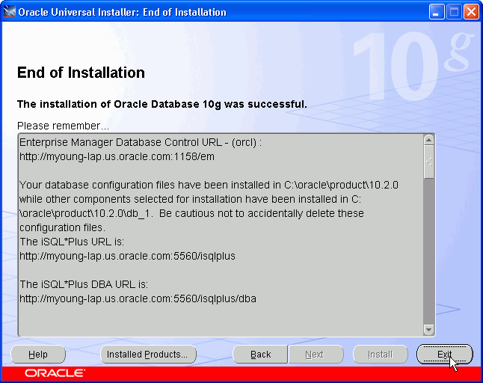  Fig. 1.13 End of Installation Screen
14. | Click Yes to confirm exit.  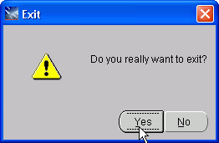  Fig. 1.14 Confirmation Window

EXPERIMENT NO. 2
OBJECTIVE:

To Create, Alter and Drop a Table.

DESCRIPTION:

- CREATE : This command is used to create a table.It is used to specify a new relation by giving it a name and specifying attributes and initial constraints. This command is a part of DDL (Data Definition Language) of SQL. The column names must be specified along the data types. Each table must have atleast one column.Tables are the basic structure where data is stored in the database. Tables are divided into rows and columns.

Syntax of CREATE command is:
Create Table <Tablename>(<column name><datatype> (<size>), <column name><datatype>(<size>), ......);

- ALTER: The definition of a base table or of other named schema elements can be changed using the ALTER command. After creating the table,we may need to change the table structures because we omit a column or our column definition needs to be changed. For this purpose, we use ALTER command.
Tables can be altered in one of the three ways:
By Adding a column to existing Table.
By changing a column’s Definition.
By Dropping a column.
ADDING a new column in a Table: We can ALTER the table by adding a new column to the existing column.
Syntax:
Alter Table <Tablename> Add (<column name><datatype> (<size>));

MODIFYING a column in a table: We can modify a column definition by using the ALTER command with the Modify clause.
Syntax:
Alter Table <Tablename> Modify (<column name><datatype> (<size>));

DROPPING a column in a table: We can drop a column from a table by using the ALTER command with the Drop column clause.
Syntax:
Alter Table <Tablename>Drop column<column name> ;

- DROP: The DROP command is used to Drop tables. This command not only deletes all the records in the table, but also removes the definition of a table. When we Drop a table, the database loses all the data in the table and all the indexes associated with it. All data is deleted from the table.

Syntax of DROP command:
DROP table <Tablename>;

EXPERIMENT NO. 3
OBJECTIVE:

To make of different clauses viz Where, Group by, Having, Order by, Union, Intersection, Set Difference.

DESCRIPTION:

1)Where: The WHERE clause is used to extract only those records that fulfill a specified criterion. It is used to specify a condition while fetching the data from single table or joining with multiple tables. If the given condition is satisfied then only it returns specific value from the table. We would use WHERE clause to filter the records and fetching only necessary records.

SQL WHERE Syntax:
SELECT column_name,column_name
FROM table_name
WHERE column_name operator value;
Where clause includes operators as:-
a)LIKE:The LIKE operator is used to search for a specified pattern in a column.
SQL LIKE Syntax:
SELECT column_name(s)
FROM table_name
WHERE column_name LIKE pattern;
The SQL LIKE clause is used to compare a value to similar values using wildcard operators. There are two wildcards used in conjunction with the LIKE operator:
- The percent sign (%)
- The underscore (_)
The percent sign represents zero, one, or multiple characters. The underscore represents a single number or character. The symbols can be used in combinations.
The basic syntax of % and _ is as follows:
SELECT FROM table_name
WHERE column LIKE 'XXXX%'

SELECT FROM table_name
WHERE column LIKE '_XXXX'

b)IN: The IN operator allows us to specify multiple values in a WHERE clause. The SQL "IN" condition helps reduce the need to use multiple SQL “OR” conditions.

SQL IN Syntax:
SELECT column_name(s)
FROM table_name
WHERE column_name IN (value1,value2,...);
c)Between: The BETWEEN operator selects values within a range. The values can be numbers, text, or dates. SQL BETWEEN Syntax:
SELECT column_name(s)
FROM table_name
WHERE column_nameBETWEENvalue1 AND value2;
2)Group By: The GROUP BY statement is used in conjunction with the aggregate functions to group the result-set by one or more columns. The GROUP BY clause must follow the conditions in the WHERE clause and must precede the ORDER BY clause if one is used.

SQL GROUP BY Syntax:
SELECT column_name, aggregate_function(column_name)
FROM table_name
WHERE column_name operator value
GROUP BY column_name;
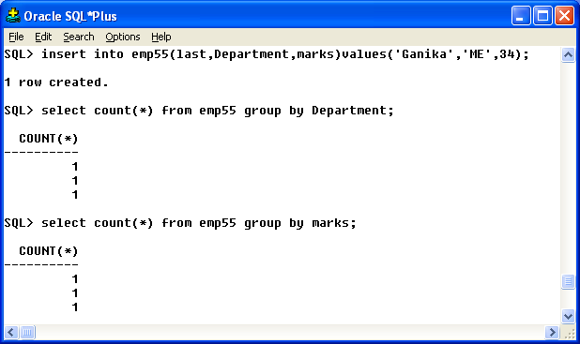
Fig. 3.1 Output of Count
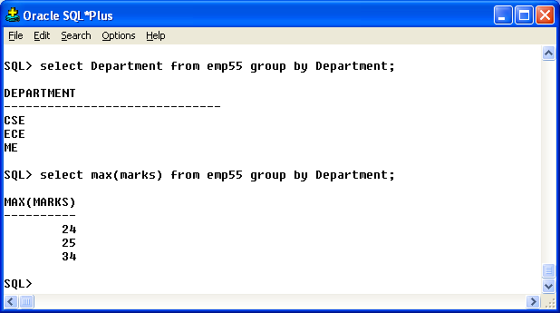
Fig. 3.2 Output of Group by
3)Having: The HAVING clause enables us to specify conditions that filter which group results appear in the final results. The WHERE clause places conditions on the selected columns, whereas the HAVING clause places conditions on groups created by the GROUP BY clause.
SQL HAVING Syntax:
SELECT column_name, aggregate_function(column_name)
FROM table_name
WHERE column_name operator value
GROUP BY column_name
HAVING aggregate_function(column_name) operator value;
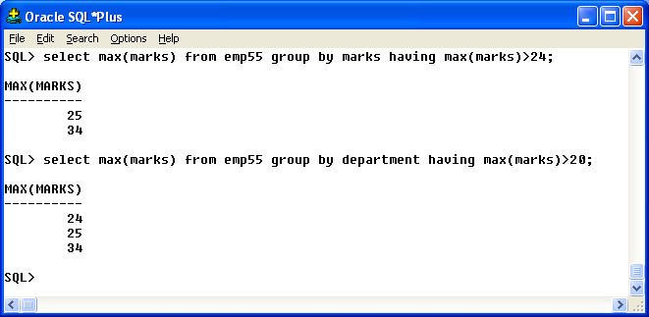
Fig. 3.3 Output of Max Command
4)OrderBy:The ORDER BY keyword is used to sort the result-set by one or more columns. The ORDER BY keyword sorts the records in ascending order by default. To sort the records in a descending order, we can use the DESC keyword. We can use more than one column in the ORDER BY clause.

SQL ORDER BY Syntax:
SELECT column_name,column_name
FROM table_name
ORDER BY column_name,column_name ASC|DESC;
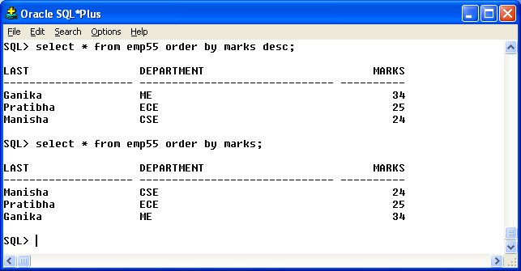
Fig. 3.4 Output of Order by

5)Union:The UNION operator is used to combine the result-set of two or more SELECT statements. Each SELECT statement within the UNION must have the same number of columns. The columns must also have similar data types.
SQL UNION Syntax:
SELECT column_name(s) FROM table1
UNION
SELECT column_name(s) FROM table2;

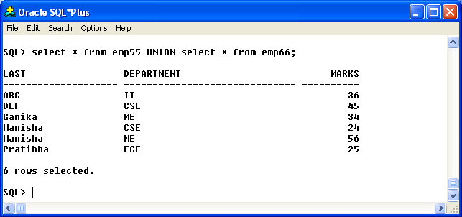
Fig. 3.5 Output of Union
6)Intersection:The SQL INTERSECT clause/operator is used to combine two SELECT statements, but returns rows only from the first SELECT statement that are identical to a row in the second SELECT statement. This means INTERSECT returns only common rows returned by the two SELECT statements.
SQL INTERSECT Syntax:
SELECT column1 [, column2 ]
FROM table1 [, table2 ]
[WHERE condition]
INTERSECT
SELECT column1 [, column2 ]
FROM table1 [, table2 ]
[WHERE condition]
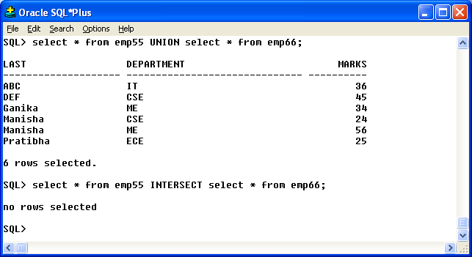
Fig. 3.6 Output of Intersect
7)Set Difference: The SQL MINUS query returns all rows in the first SQL SELECT statement that are not returned in the second SQL SELECT statement.
Each SQL SELECT Statement within the SQL MINUS query must have the same number of fields in the result sets with similar data types.
SQL MINUS syntax:
SELECT field1, field2, ...field_n
FROM tables
MINUS
SELECT field1, field2, ...field_n
FROM tables;

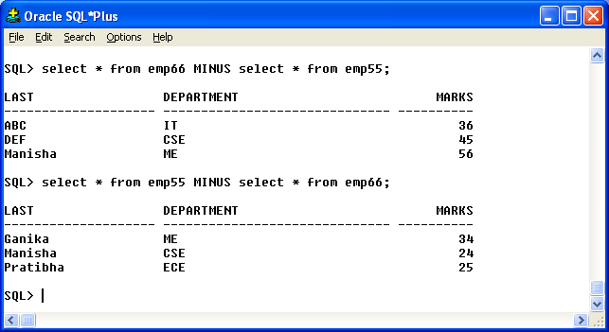
Fig. 3.7 Output of Minus

EXPERIMENT NO. 4
OBJECTIVE:

To understand the use and working of Joins.

DESCRIPTION:

Join: SQL joins are used to relate information in different tables. Joins are used to combine columns from different tables. The connection between tables is established through the where clause. There are five types of Joins:
- Equijoins.
- Cartesian Joins.
- Outer Joins.
- Non-Equi Joins
- Self Joins.

- Equijoin: When two tables are joined together using equality of values in one or more columns, they make an Equijoin. Table prefixes are utilized to prevent ambiguity and the where clause specifies the columns being joined. Equijoins are also called Simple Joins or Inner Joins.
Syntax of Equijoin is:
Select <column name>,<column name> from Table1 t1,Table2 t2 where <condition>;

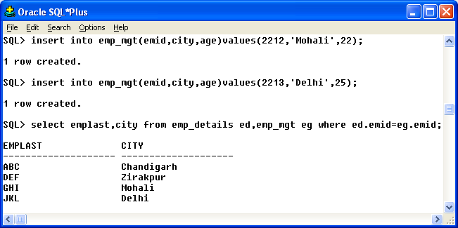
Fig. 4.1 Output of Select Command
- Cartesian Join: The Cartesian Product returns the number of rows equal to the product of all rows in all the tables being joined. Cartesian product is useful in finding out all the possible combination of columns from different tables.

Syntax of Cartesian Join is:
Select <column name>,<column name> from Table1 t1,Table2 t2;

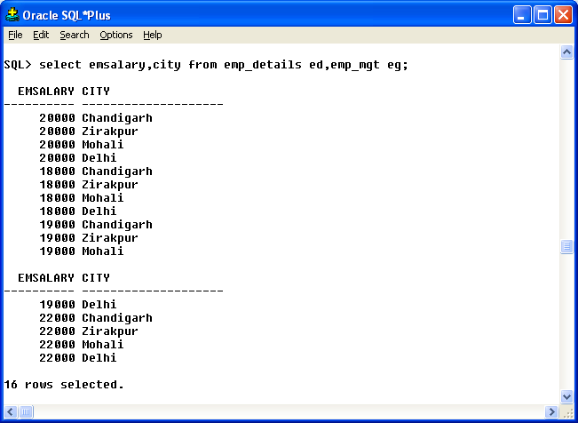
Fig. 4.2 Output of Joining two tables

- Outer Join: This SQL Join condition returns all rows from both tables which satisfy the Join condition along with rows which do not satisfy the Join condition from one of the tables. The Outer Join is used in such cases where any values in one table that do not have corresponding value in other table. We have further three types of Outer Join:
- Left Outer Join.
- Right Outer Join.
- Full Outer Join.
Syntax of Left Outer Join is:
Select <column name>, <column name> from Table1 t1 left outer join Table2 t2 on (condition);
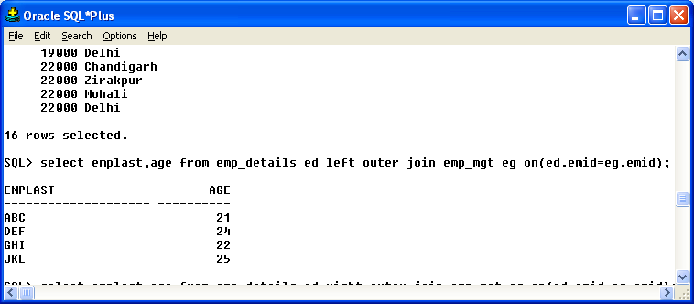
Fig. 4.3 Output of Left Outer Join

Syntax of Right Outer Join is:
Select <column name>, <column name> from Table1 t1 right outer join Table2 t2 on (condition);

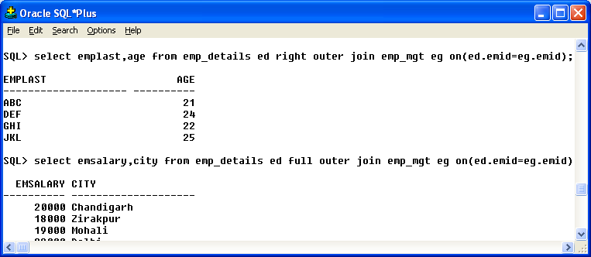
Fig. 4.4Output of Right Outer Join

Syntax of Full Outer Join is:
Select <column name>, <column name> from Table1 t1 full outer join Table2 t2 on (condition);

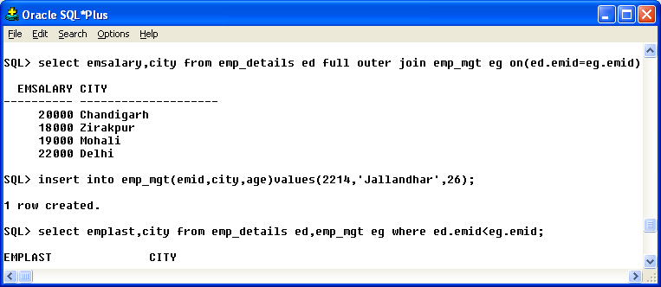
Fig. 4.5Output of Full Outer Join

- Non-Equi Join: When two or more tables are joined together using non-equality of values in one or more columns, they make a Non-Equi Join.

Syntax of Non-Equi Join is:
Select <column name>, <column name> from Table1 t1,Table2 t2 where <condition>;

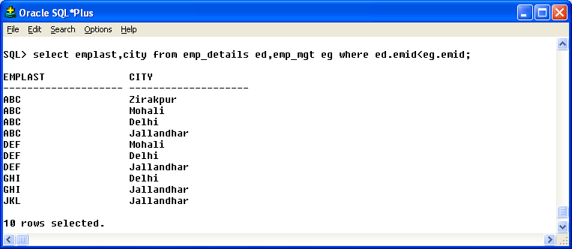

Fig. 4.6Output of Non Equi-join

- Self Join: Self Join is to join a table to itself means that each row of the table is combined with itself and with every other row of the table. This type of join is used when a table has a foreign key that references its own primary key. The self join can be viewed as join of two copies of the same table.

Syntax of Self Join is:
Select <column name> from Table1 where <condition>;

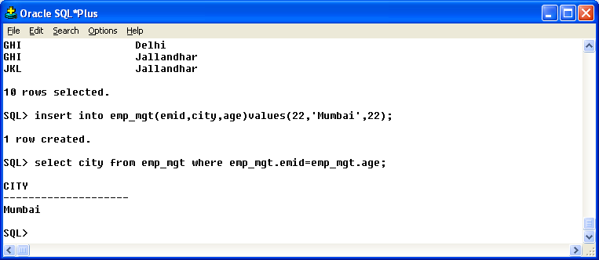
Fig. 4.7Output of Self-Join

EXPERIMENT NO. 5
OBJECTIVE:

To understand the use and working of Sub-Queries.

DESCRIPTION:

Sub-Query: Some Queries require that existing values in the database be fetched and then used in a comparison condition. Such Queries can be conveniently formulated by using Sub-Queries or Nested Queries, which are complete select-from-where blocks within the WHERE clause of another query. That other Query is called the Outer Query.
- Single Row Sub-Query: Sub-queries that can return only one or zero rows to the outer statement are called single row sub-queries. Single rows sub-queries are sub-queries used with a comparison operator in a where or having clause.
Syntax of Single Row Sub-query is:
Select <column name1> from Table1 where <column name> IN (select <column name> from Table2 where <condition>);

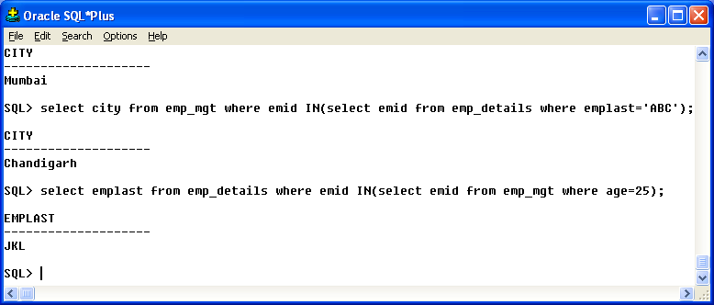
Fig. 5.1 Output of Subquery

- Multiple Row Sub-Query: Sub-queries that can return more than one rows to the outer statement are called multiple row sub-queries. Multiple row sub-queries are sub-queries used with an IN,ANY or ALL clause.
Syntax of Single Row Sub-query is:

Select * from Table1 where <column name> IN (select <column name> from Table2 where <condition>);

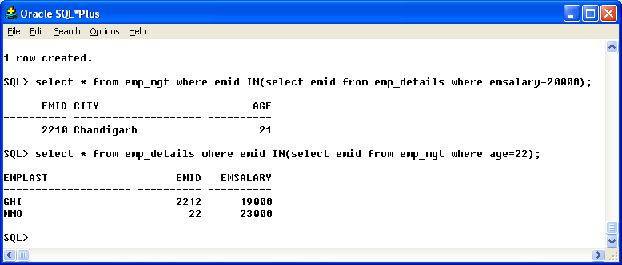

Fig. 5.2 Output of Multi Row Subquery

EXPERIMENT NO. 6
OBJECTIVE:

To perform aggregate functions like SUM, MAX, MIN, AVG, COUNT on a table.

DESCRIPTION:

Aggregate Functions: An aggregate function is a function where the values of multiple rows are grouped together as input on certain criteria to form a single value of more significant meaning or measurement.
- SUM: The SUM () function returns the total sum of a numeric column. SQL SUM () function to sum one or more columns against one or more conditions.
Syntax:
Select SUM (<column name>) from <table name>;

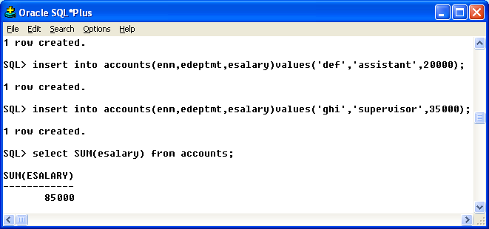
Fig. 6.1Output of Sum Function

- MAX: This function returns the maximum of values for any column of a table for all the rows.
Syntax:

Select MAX(<column name>) from <table name>;
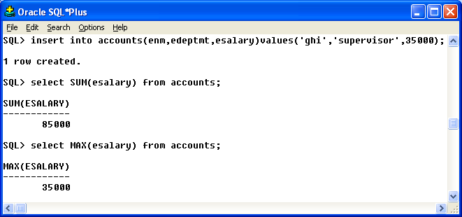
Fig. 6.2 Outputof Max

- MIN: This function returns the minimum of values for any column of a table for all the rows.
Syntax:
Select MIN(<column name>) from <table name>;

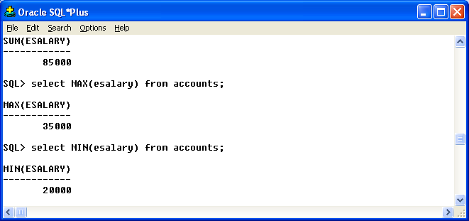
Fig. 6.3Output of Min

- AVG: Ths function returns the average of values for any column of a table. It ignores the null values in the column.
Syntax:
Select AVG(<column name>) from <table name>;

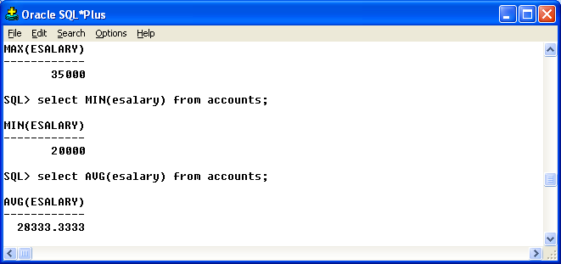
Fig. 6.4Output of Avg Function

- COCOUNT: :This function returns the number of rows or non-null values for any given column in a table.
Syntax:
Select COUNT(<column name>) from <table name>;
Select COUNT(*) from <table name>;

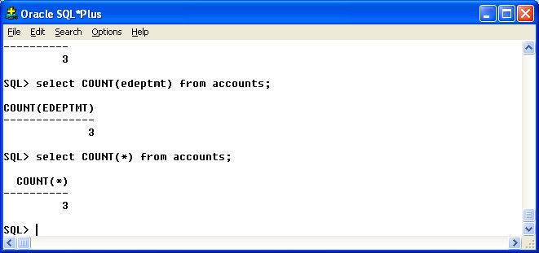
Fig. 6.5Output of Count

EXPERIMENT NO. 7
OBJECTIVE:

To perform Data Security and Privileges Command: Grant and Revoke, Rollback and Commit on a
table.

DESCRIPTION:

- Grant: SQL GRANT is a command used to provide access or privileges on the database objects to the users.
Syntax:
GRANT Select <privileges_list> ON <table name> to System;

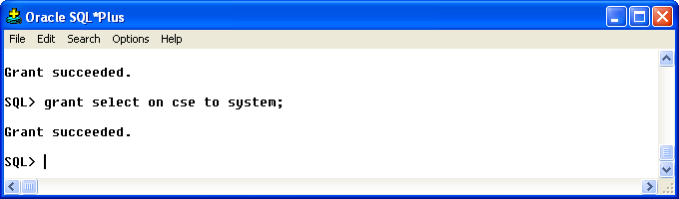
Fig. 7.1 Output of Grant

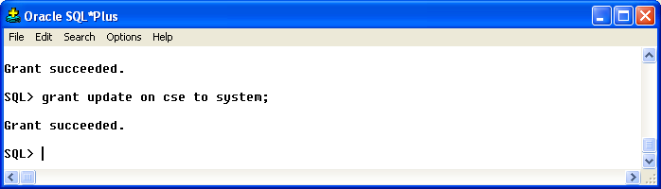
Fig. 7.2 Result of Grant

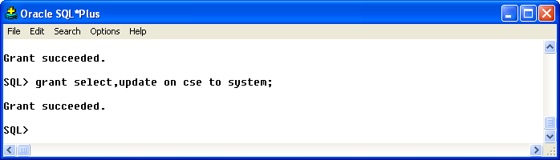
Fig. 7.3Output 2 of Grant

- Revoke: The REVOKE command removes user access rights or privileges to the database objects.
Syntax:
REVOKE Select <privileges_list> ON <table name> from System;

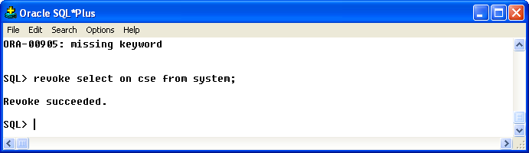
Fig. 7.4 Output of Revoke

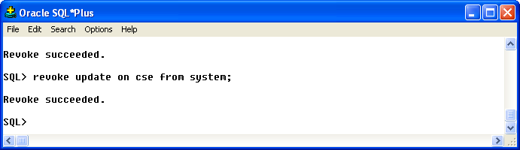
Fig. 7.5 Output 2 of Revoke

- Rollback: The ROLLBACK command is the transactional command used to undo transactions that have not already been saved to the database. The ROLLBACK command can only be used to undo transactions since the last COMMIT or ROLLBACK command was issued.
Syntax:
Rollback;

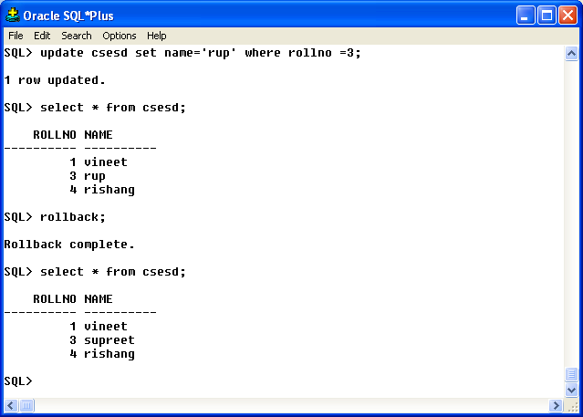
Fig. 7.6 Output of Rollback

- Commit: The COMMIT command is the transactional command used to save changes invoked by a transaction to the database. The COMMIT command saves all transactions to the database since the last COMMIT or ROLLBACK command.
Syntax:

Commit;

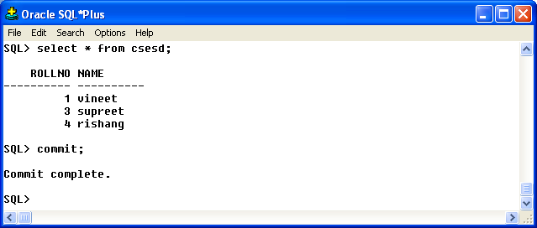

Fig. 7.7Output of Commit

EXPERIMENT NO. 8
OBJECTIVE:

To make Views of a table and to perform Insert, Update ,Select and Delete operations on View.

DESCRIPTION:

Views: To reduce redundant data to the minimum possible, Oracle allows the creation of an object called a view. A View is mapped, to a Select sentence. This technique offers a simple, effective way of hiding columns of a table.
Syntax:
Create view <view_name> AS select <column_list> from <table_name>;

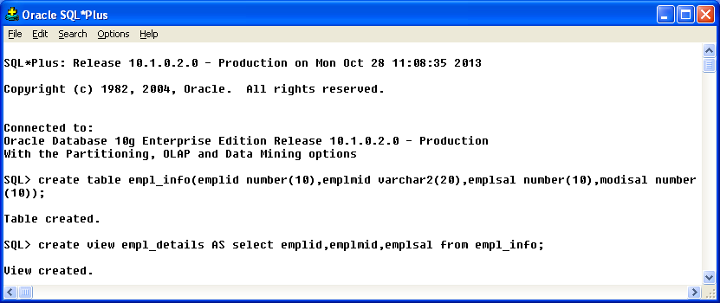
Fig. 8.1Output of Views

Insertion in Views: It is used to Insert rows in views. We must specify a list of values for a particular row.
Syntax:
Insert into <view_name> values <list of values>;

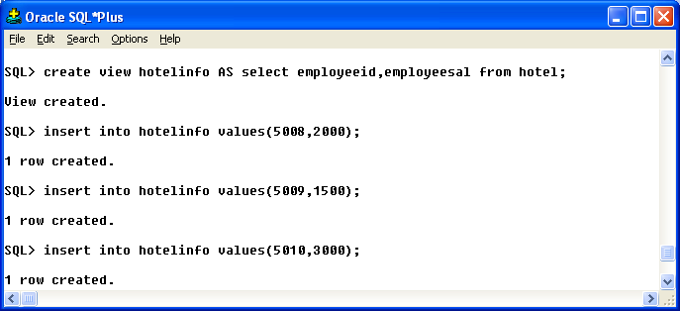
Fig. 8.2Output of Insert

Updation in Views: Columns in a view can be updated. It is used to modify attribute values of one or more selected rows. Values of a single column or group of columns can be updated.
Syntax:
Update <view_name> set <column name> = <value> where <condition>;

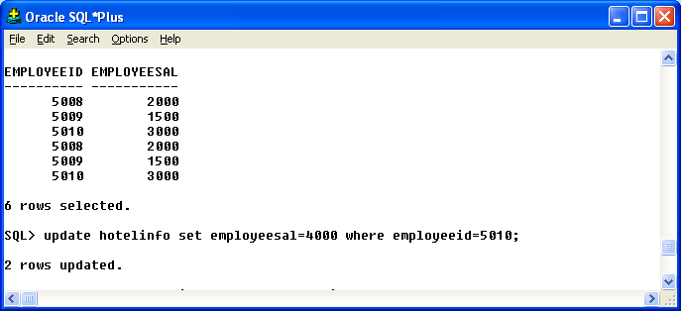
Fig. 8.3Output of Update View

Selection in Views: SELECT is used to retrieves information from the view.
Syntax:
Select <column list> from<view_name>;

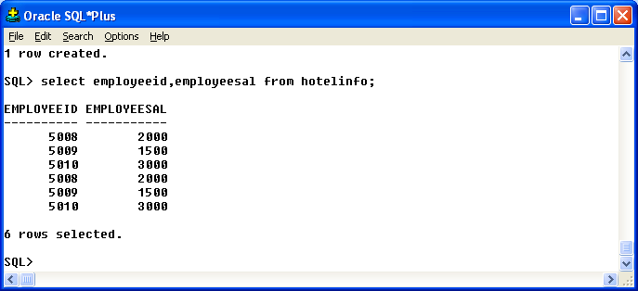
Fig. 8.4Output of Selection from View

Deletion in Views: It is used to remove existing rows from a view. The entire row is deleted from the view. A set of rows can also be deleted from the table by specifying the condition.
Syntax:
Delete from <view_name> where <condition>;

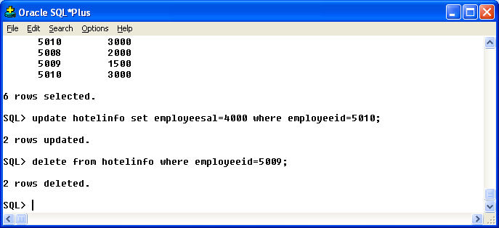
Fig. 8.5Output of deletion from View

EXPERIMENT NO. 9
OBJECTIVE:

To make indexes and sequences for a table.

DESCRIPTION:

Indexes: An Index is a database object that is used by the server to find a row in a table quickly. Indexing a table is an access strategy, that is , a way to sort and search records in the table. Indexes are essential to improve the speed with which the records can be located and retrieved from a table.
- Indexes are of two types:
- Simple Index.
- Composite Index.

- Simple Index: An Index created on a Single Column of a table is called a simple Index.
Syntax:
Delete from <view_name> where <condition>;

- Composite Index: An Index Created on more than one column is called a Composite Index.
Syntax:
Delete from <view_name> where <condition>;

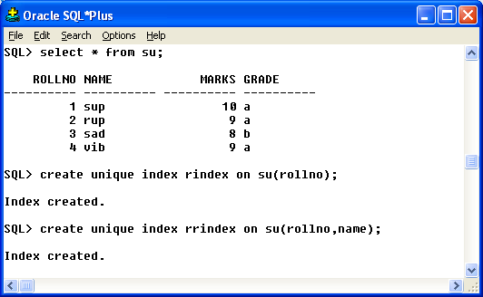
Fig. 9.1Output of Unique Index

Sequences: Sequence is a database object from which multiple users may generate unique integers. We can use sequences to automatically generate primary key values.

Syntax:
Create Sequence <Sequence name> incremented by 1 <conditions>;

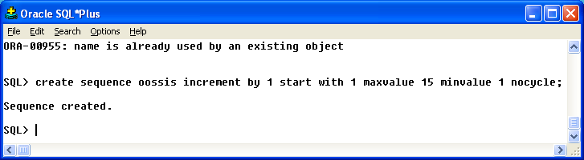
Fig. 9.2 Output of Sequence

EXPERIMENT NO. 10

OBJECTIVE:

Introduction To PL/SQL Architecture.

DESCRIPTION:

PL/SQL:
PL/SQL stands for Procedural Language extension of SQL.
PL/SQL is a combination of SQL along with the procedural features of programming languages.
It was developed by Oracle Corporation in the early 90’s to enhance the capabilities of SQL.
EXECUTION OF PL/SQL BLOCK:
The PL/SQL statements written on the client side are passed to the PL/SQL engine at server side and all the SQL statements are send to the SQL executer. After the execution of whole block the result is send back to the client side. The execution of the whole block is done in one go.
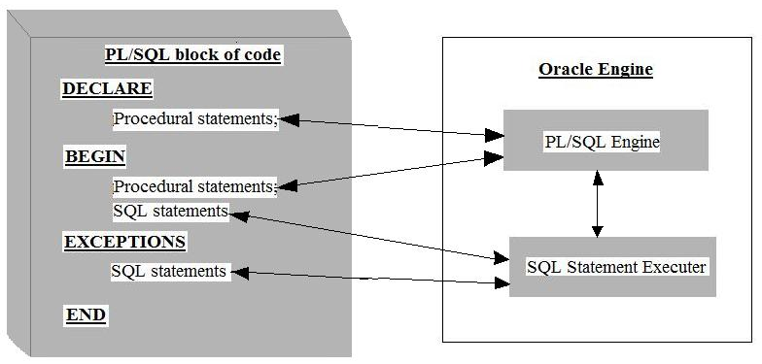
Fig. 10.1 Execution of PL/SQL block

DIFFERENCE BETWEEN SQL & PL/SQL:
SQL | PL/SQL
It does not offer procedural statements (control statements). | It offers procedural statements.
No position for generating users own error messages. | It can generate users own error messages.
It does not allow a group of statements to be sent to oracle engine at a time. | It allows group of statements to be sent to oracle engine at a time.
It does not allow the use of variables to store the intermediate results. | It allows the use of variables to store the intermediate results.
SQL does not support PL/SQL statements. | PL/SQL supports SQL statements.
It is easy to understand. | It is difficult to understand.
It takes less time to execute. | It Takes more time to execute.

EXPERIMENT NO. 11
OBJECTIVE:

Compute Addition,Subtraction,Product and Division of given two numbers.

DESCRIPTION:

SQL>
declare
a number:=&a;
b number:=&b;
r1 number;
r2 number;
r3 number;
r4 number;
begin
r1:=a+b;
r2:=a-b;
r3:=a*b;
r4:=a/b;
dbms_output.put_line('RESULT = '||r1);
dbms_output.put_line('RESULT = '||r2);
dbms_output.put_line('RESULT = '||r3);
dbms_output.put_line('RESULT = '||r4);
end;

Output:

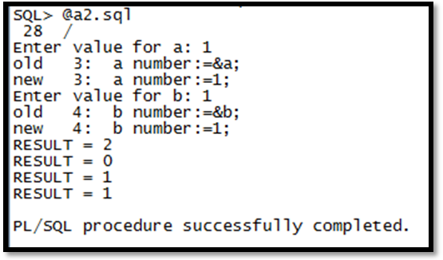

EXPERIMENT NO. 12
OBJECTIVE:

To Print Multiplication Table of a number.

DESCRIPTION:

SQL>
Declare
table_of number := &enter_table_of;
cnt number := 1;
Result number;
Begin
while (cnt<= 10)
loop
Result :=table_of number * cnt;
DBMS_output.put_line(table_of number|| '*' || '=' || Result);
cnt := cnt + 1;
end loop;
end;

Output:

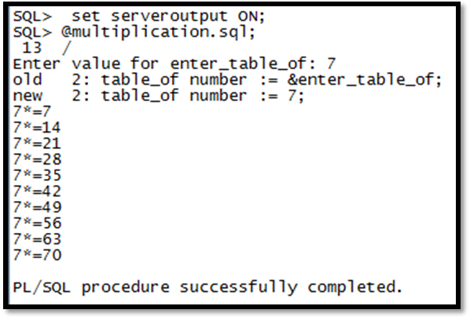

EXPERIMENT NO. 13
OBJECTIVE:

For Loop – To Find Reverse of a given number.

DESCRIPTION:

SQL>
Declare
gvn_novarchar(5) := '6789';
str_length number(2);
inverted_novarchar(5);
Begin
str_length := length(gvn_no);
forcntr IN Reverse 1..str_length
loop
inverted_no := inverted_no || substr(gvn_no,cntr,1);
End loop;
DBMS_output.put_line('given no. is' || gvn_no);
DBMS_output.put_line('inverted no. is' || inverted_no);
end;

Output:

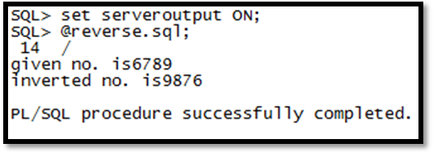

EXPERIMENT NO. 14
OBJECTIVE:

Implementation Of Procedure.

DESCRIPTION:

PROCEDURES:

Procedures are named PL/SQL blocks that can take parameters, perform an action and can be invoked. A procedure is generally used to perform an action and to pass values Procedures are made up of:
1. A declarative part,
2. An executable part and
3. An optional exception-handling part.

Declarative part:The declarative part may contain declarations of cursors, constants, variables, exceptions and subprograms. These objects are local to the procedure. The objects become invalid once you exit from it.

Executable part: This part contains PL/SQL block consisting of statements that assign values, control execution and manipulate ORACLE data.

Exception handling part:This part contains code that performs action to deal with exceptions raised during the execution of the executable part.

Syntax
CREATE OR REPLACE
PROCEDURE [schema.] procedurename
(argument {IN, OUT, IN OUT} datatype,) {Is, AS}
variable declarations;
constant declarations;
BEGIN
PL/SQL subprogram body;
EXCEPTION
Exception PL/SQL block;
END;

TYPES OF PROCEDURES:
- Local procedure.
- Stored procedure.

LOCAL PROCEDURES:

These procedures are declare within the PL/SQL block and called from the begin section of the PL/SQL block.

The following is a simple example of a procedure:

PROGRAM:
declare
a number;
b number;
c number;
d number;
e number ;
f number;
procedure process ( a in number ,b in number,c out number,d out number,e out number,f out number) is
begin
c:=a+b;
d:=a-b;
e:=a*b;
f:=a/b;
end;
begin
a:=&firstnumber;
b:=&secondnumber;
process(a,b,c,d,e,f);
dbms_output.put_line('addition is'||c);
dbms_output.put_line('subtraction is'||d);
dbms_output.put_line('multiplication is'||e);
dbms_output.put_line('division is'||f);
end;

OUTPUT:-

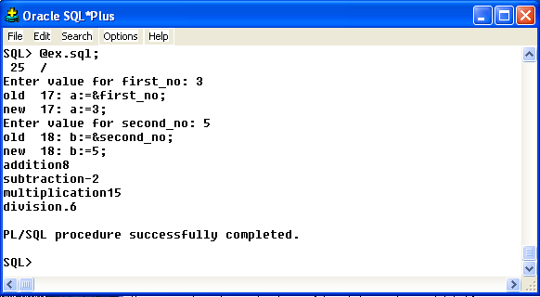

Fig. 14.1Output of PL/SQL

EXPERIMENT NO. 15

OBJECTIVE:

Implementation of Triggers.

DESCRIPTION:

TRIGGERS:
A trigger is a special kind of stored procedure that is invoked whenever an attempt is made to modify the data in the table it protects. Modifications to the table are made using INSERT, UPDATE,OR DELETE statements.Triggers are used to enforce data integrity and business rules such as automatically updating summary data. It allows performing cascading delete or updating operations. If constraints exist on the trigger table,they are checked prior to the trigger execution. If constraints are violated statement will not be executed and trigger will not run.Triggers are associated with tables and they are automatic. Triggers are automatically invoked by SQL SERVER. Triggers prevent incorrect,unauthorized,or inconsistent changes to data.

USES OF TRIGGERS:
- A trigger can permit DML statements against a table only if the are issued, during regular business hours or on predetermined weekdays.
- A trigger can also be used to keep an audit trail of a table.
- It can be used to prevent invalid transactions.
- Enforce complex security authorizations.
- Exception handling.
- Generation of primary key and foreign key.

HOW TO APPLY TRIGGERS:
A trigger has three basic parts:
- Triggering Event or Statement:
It is a SQL statement that causes a trigger to be fired. It can be a INSERT, UPDATE, or DELETE statement for a specific table.

- Trigger Restriction:
A trigger restriction specifies a Boolean expression that must be TRUE for the trigger to fire. It is an option available for triggers that are fired for each row. A trigger restriction is specified using a WHEN clause.

- Trigger Action:
A trigger action is the PL/SQL code to be executed when a triggering statement is encountered and any trigger restriction evaluates to TRUE.

TYPES OF TRIGGERS:

- ROW TRIGGERS:
A row trigger is fired each time the table is affected by the triggering statement, for example ,if an UPDATE statement update multiple rows of a table, a row trigger is fired once for each row affected by the UPDATE statement.
- STATEMENT TRIGGERS:
A row trigger is fired once on behalf of the triggering statement, independent of the number of rows the triggering statement affects.
- BEFORE TRIGGERS:
Before triggers execute the trigger action before the triggering statement. These types of triggers are commonly used in the following situations:
- BEFORE triggers are used when the trigger action should determine whether or not the triggering statement should be allowed to complete. By using BEFORE trigger, user can eliminate unnecessary processing of the triggering statement.
- BEFORE triggers are used to derive specific column values before completing a triggering INSERT or UPDATE statement.
- AFTER TRIGGERS:
After triggers execute the trigger after the triggering statement is executed. These types of triggers are commonly used in the following situations:
- AFTER triggers are used when the triggering statement should complete before executing the trigger action.
- If a BEFORE trigger is already present, an AFTER trigger can perform different actions on the same triggering statement.

COMBINATIONS TRIGGERS

Using the above triggers, four types of triggers could be created. There are twelve combinations of triggers.

BEFORE statement trigger

Before executing the triggering statement, the trigger action is executed.

BEFORE row trigger

Before modifying each row affected by the triggering statement and BEFORE applying appropriate integrity constraints, the trigger is executed.

AFTER Statement trigger

After executing the triggering statement and applying and deferred integrity constraints, the trigger action is executed.

AFTER Row Trigger

After modifying each row affected by the triggering statement and applying appropriate integrity constraints, the trigger action is executed for the current row. Unlike BEFORE row triggers, AFTER row triggers have rows locked.

CREATION OF TRIGGERS:
Triggers are created with the CREATE TRIGGER statement. This statement specifies that the on which table trigger is defined and on which events trigger will be invoked.

Syntax:

CREATE OR REPLACE TRIGGER [Schema.] <TriggerName>
{BEFORE, AFTER, Instead of}
{DELETE,INSERT,UPDATE [OF Column,…]}
ON[Schema.] <Tablename>
[REFERENCING {OLD AS old, NEW as new}]
[FOR EACH ROW [WHEN condition]]
DECLARE
<Variable declarations>;
<Constant declarations>;
BEGIN
<PL/SQL subprogram body>;
EXCEPTION
<Exception PL/SQL block>;
END;

DELETING A TRIGGER:

To drop Trigger one can use DROP TRIGGER statement.

SyntaxDROP TRIGGER <TriggerName>

EXPERIMENT NO. 16

OBJECTIVE:

Implementation of Cursor.

DESCRIPTION:

CURSORS:
Oracle DBA uses a work area for its internal processing. This work area is private to SQL’s operations and is called Cursor. The data that is stored in the cursor is called the Active Data Set. The size of the cursor in memory is the size required to hold the number of rows in the active data set.
A PL/SQL block of code includes the Procedural code for looping and branching along with the SQL statement. If records from a record set created using a select statement are to be evaluated and processed one at a time, then the only method available is by using Explicit Cursors.

TYPES OF CURSORS:
- Implicit cursors.
- Explicit cursors.

ATTRIBUTES OF CURSORS: Oracle provides certain attributes/cursor variables to control the exception of a cursor. Whenever any cursor is opened and used, Oracle creates a set of four system variables via which Oracle keeps track of the ‘Current’ status of the cursor. We can access these variables. The implicit and explicit cursors have four attributes as described below:

i)%NOTFOUND: It evaluates to TRUE, if an insert, delete ,or updateaffected no rows or a single row select returns no rows. Otherwise, it evaluates to FALSE.

Syntax:
cursor_name%NOTFOUND;

ii)%FOUND: It is the logical opposite of %notfound. It evaluates to TRUE, if an insert, delete ,orupdateaffected one or more rows, or a single row select returns one or more rows. Otherwise, it evaluates to FALSE.

Syntax:
cursor_name%FOUND;

iii)%ISOPEN: Oracle automatically closes the SQL cursor after executing its associated SQL statement. As a result, sql%isopenalways evaluates to FALSE. If the explicit cursor is open then it returns true otherwise false.

Syntax:
cursor_name%ISOPEN;
iy) %ROWCOUNT: Returns the number of rows affected by an insert, delete ,or updateor selectinto statement.

Syntax:
cursor_name%ROWCOUNT;

IMPLICIT CURSORS:
Oracle implicitly opens a cursor to process each SQL statement not associated with an explicitly declared cursor. PL/SQL lets us refer to the most recent implicit cursor as the SQL cursor. So, although we cannot use the open, fetch, and closestatements to control an implicit cursor, we can still use cursor attributes to access information about the most recently executed SQL statement.

Use cursor to select the five highest paid employees from the emp table showing tables also.

Input Table:

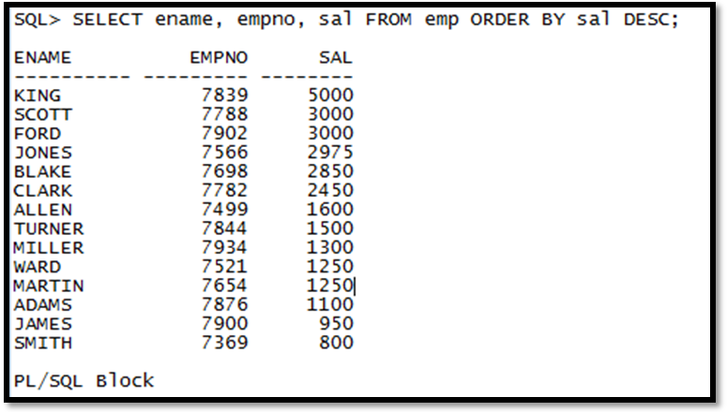

Declare
cursor c1 is
selectename, empno, sal from emp
order by saldesc; -- start with highest paid employee
my_enamevarchar2(10);
my_empno number(4);
my_sal number(7,2);
Begin
open c1;
fori in 1..5 loop
fetch c1 into my_ename, my_empno, my_sal;
exit when c1%notfound;
insert into temp values (my_sal, my_empno, my_ename);
commit;
end loop;
close c1;
end;

Output Table:

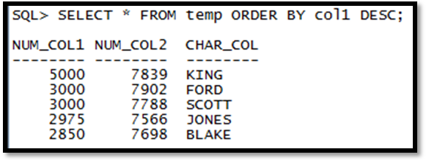

QUESTIONS FOR VIVA-VOCE:

- Why a database is called as relational database model?
- What are entities and attributes referring to?
- What do you understand by relation in relational database model?
- Why domain is of high importance?
- What are constraints in database?
- What are the two principles of relational database model? What is the difference between them?
- What is the difference between primary and foreign key?
- What do you understand by cardinality and why it is used?
- What is the difference between DBMS and RDBMS?
- What is the syntax of create command?
- Why create command is used?
- What is the syntax of alter command?
- Why alter command is used?
- What is drop command used for?
- What is the syntax od drop command?
- Why we use WHERE clause?
- Why we use LIKE operator?
- Why we use ORDER BY clause?
- What can be used with LIKE operator?
- Why is the function of IN,BETWEEN and GROUP BY clause?
- What is function of IN operator?
- What is the syntax of INTERSECT command?
- Why INTERSECT command is used?
- What is the syntax of MINUS command?
- Why MINUS command is used?
- What is UNION command used for?
- What is the syntax of UNION command?
- Why HAVING command is used?
- What is the syntax of HAVING command?
- What do you mean by Sub –query? Why it is used?
- What is the syntax of Sub query?
- What do you mean by multiple Row Sub –query? What is the syntax of it?
- What do you mean by join?
- What is equijoin? Why we use it?
- What is the syntax of equijoin?
- What is Cartesian Join? Why we use it?
- What is the syntax of Cartesian Join?
- What is Outer join? Why we use it?
- What is the syntax of Outer join?
- What is Left Outer join? Why we use it?
- What is the syntax of Left Outer join?
- What is Right Outer join? Why we use it?
- What is the syntax of Right Outer join?
- What is Full Outer join? Why we use it?
- What is the syntax of Full Outer join?
- What is non equijoin? Why we use it?
- What is the syntax of non equijoin?
- What is self join? Why we use it?
- What is the syntax of self join?
- Explain what is function?
- What is the syntax of SUM function and why it is used?
- What is the syntax of MAX function and why it is used?
- What is the syntax of MIN function and why it is used?
- What is the syntax of AVG function and why it is used?
- What is the syntax of COUNT function and why it is used?
- Why there is need of data security?
- What do you mean by priviliges?
- What commands come under priviliges command?
- What is GRANT command? What is its syntax?
- What is REVOKE command? What is its syntax?
- What is ROLLBACK command? What is its syntax?
- What is COMMIT command? What is its syntax?
- What is the need of making Views?
- What is the syntax of Views?
- How inserting is done on views?
- How selection is done on views?
- How updation is done on views?
- How deletion is done on views?
- Why there is need of Indexing?
- What is the syntax of Index?
- Why there is need of Sequencing?
- What is the syntax of Sequence?
- What is the purpose of the PL/SQL language?
- State few notable characteristics of PL/SQL.
- Name few schema objects that can be created using PL/SQL?
- State some features or programming constructs supported by PL/SQL.
- What do you mean by exception?
- What are the three basic sections of a PL/SQL block?
- Difference between SQL and PL/SQL?
- How will you do addition in PL/SQL?
- How will you do subtraction in PL/SQL?
- How will you do multiplication in PL/SQL?
- How will you do division in PL/SQL?
- How will you make tables in PL/SQL?
- How will you find reverse of a number in PL/SQL?
- What is procedure?
- What is the syntax of procedure?
- What is the use of making procedures?
- What is local procedure?
- Why stored procedures are called as executable code?
- What is trigger?
- What is the syntax of trigger?
- What is the need of making trigger?
- What are the different types of trigger ?
- How can be a trigger gets deleted?
- What is cursor?
- What is the syntax of cursor?
- What is the need of making cursor?
- What are the different types of cursors ?
- How can be a cursor gets deleted?

